# GSPN Model 2020

## Objectives:

* Create python script for GSPN model creation and evaluation
* To refresh co-efficient of current GSPN model
* Evaluate new predictors: Geo-Score, POS Type, POS Productivity, DDM%
* Evaluate performance of AF delinquency measures (as a replacement of UW ones)
* POS grouping to be done based on WOE and IV optimizations

## Key Parameters:

Target Variable: FSTQPD60

Train Set: May’19-Jun’19

Test Set: Jul’19 Onwards

## Results:

### MOM Gini Trends

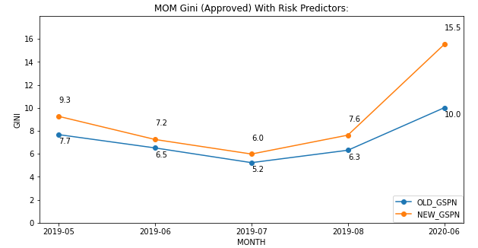

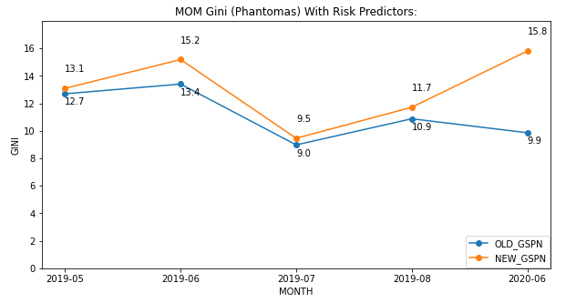

FSTQPD60 trends in OLD and NEW GSPN:  
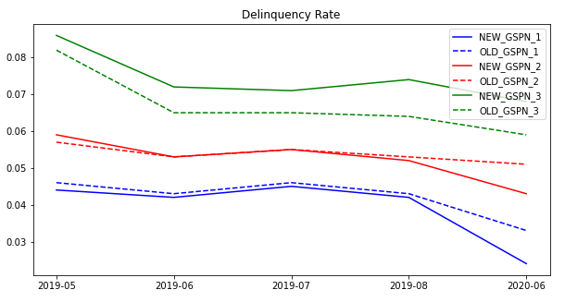

### Population Shift:

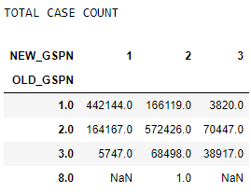 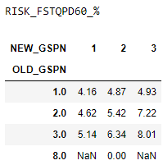

### Marginal Gini Contribution of Predictors Considered for modelling:

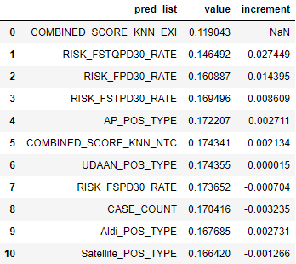

### Selected Predictors:

## Variables Definition:

* **COMBINED_SCORE_KNN_EXI:** Geo Delinquency score based on the Grid-ID of POS
* **RISK_FSTQPD30_RATE:** FSTQPD30 rate of contracts created b/w D-270 and D-211
* **RISK_FPD30_RATE:** FPD30 rate of contracts created b/w D-120 and D-0
* **RISK_FSTPD30_RATE:** FSTPD30 rate of contracts created b/w D-210 and D-151

## AF Predictor Analysis summary:

Instead of delinquency rate in terms of UW definition, we took AF definition as below:

* **FPD30:** RISK_FPD30/RISK_AGRF30 over contracts with due date b/w D-90 to D-31
* **FSPD30:** (RISK_FPD30+RISK_FSPD30)/(RISK_AGRF30+RISK_AGRF60) over contracts with due date b/w D-120 to D-91
* **FSTPD30:** (RISK_FPD30+RISK_FSPD30+RISK_FSTPD30)/(RISK_AGRF30+RISK_AGRF60+RISK_AGRF90) over contracts with due date b/w D-180 to D-121
* **4PD30:** (RISK_FPD30+RISK_FSPD30+RISK_FSTPD30+FSTQPD30)/(RISK_AGRF30+RISK_AGRF60+RISK_AGRF90+RISK_AGRF120) over contracts with due date b/w D-240 to D-181

Remaining predictors were same in the analysis. The performance of this model was lower than the one with UW defined delinquency by ~2% gini pts.

## Key Changes over Current GSPN Model:

* Delinquency rate used as predictor in place of Binomial Probabilities
* Null values in delinquency rate predictors replaced with avg. values against 0.5
* Addition of Geo-Score in predictor list
* Target variable: RISK_FSTQPD60

## Python Script



## Appendix

### MOM Gini trends on shorter delinquencies

